Data Structures and Algorithm
Chapter 1: Time and Space Complexity
When we write a program, we care about how fast it runs and how much memory it uses. That’s what Time Complexity and Space Complexity measure.
1.1 What is Time Complexity?
Time Complexity tells us how the running time of a program increases as the size of the input (n) increases.
- It does not measure actual seconds.
- It measures growth rate — how fast time increases when input grows.
We express it in Big O Notation.
💬 Example:
If your program takes 1 second for 10 inputs and 2 seconds for 20 inputs, time roughly doubles when input doubles — that’s O(n) (linear growth).
1.2 Time Complexity Analysis: (In Big-O notation)
- Best Case: Ω(1), This will take place if the element to be searched is on the first index of the given list. So, the number of comparisons, in this case, is 1.
- Average Case: O(n), This will take place if the element to be searched is on the middle index of the given list.
- Worst Case: O(n), This will take place if:
  - The element to be searched is on the last index
  - The element to be searched is not present on the list
Important Point:
- Most of the times, we do the worst-case analysis to analyse algorithms. In the worst analysis, we guarantee an upper bound on the running time of an algorithm which is a good piece of information.

1.3 Big O Notation
To Calculate it, ignore lower order terms and ignore leading term constant.
- A logarithmic algorithm - O(logn) Runtime grows logarithmically in proportion to n.
- A linear algorithm - O(n) Runtime grows directly in proportion to n.
- A super linear algorithm - O(nlogn) Runtime grows in proportion to n.
- A polynomial algorithm - O(n^{c}) Runtime grows quicker than previous all based on n.
- An exponential algorithm - O(c^{n}) Runtime grows even faster than polynomial algorithm based on n.
- A factorial algorithm - O(n!) Runtime grows the fastest and becomes quickly unusable for even small values of n.
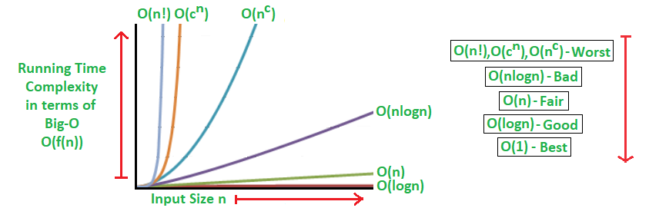
How do we compare terms?
O(1) < O(log(log n)) < O(log n) < O(n) < O(n²) < - - - - < O(n^{c}) < O(c^{n}) < O(n!)

1.4 Analysis of Algorithms
1.4.1 Constant Time Algorithm or O(1)
Time Complexity of a function will be considered as O(1) if it does not contain any loop, recursion and call to any other non-constant time function.
Example:
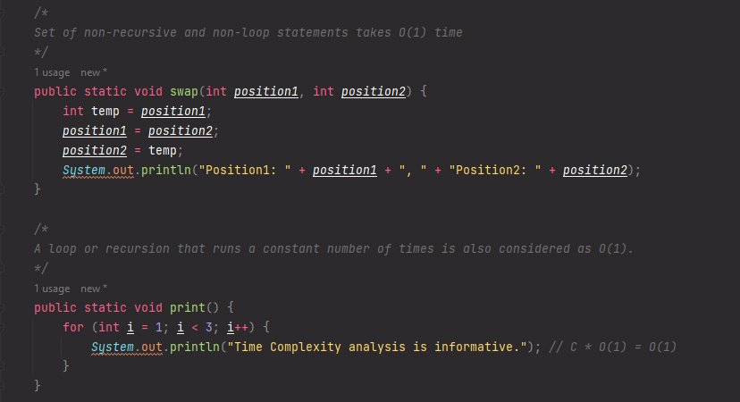
1.4.2 Sub Logarithmic Time Algorithm or O(log log n)
Time Complexity of a loop is considered as O(log log n) if the loop variables is increment/decrement by exponentially by a constant amount.
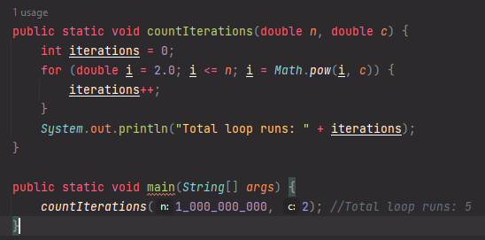
Only 5 iterations for 1 billion.
n=1_000_000_000 | i₀=2⁰ | i=2
c=2 | i₁=2² | i=4
 | i₂=4² | i=16
 | i₃=16² | i=256
 | i₄=256² | i=65536
 | i₅=65536² | i=stop because > n

As loop runs from i=2 and i is exponentially squared by constant factor c
2,2²,(2²)² - - - - - $2^{c^{c^{c}}}$
Let assume loop runs K times
$2^{c^{0}}$ , $2^{c^{0}}$ , $2^{c^{0}}$ - - - - - - $2^{c^{k-1}}$
$2^{c^{k-1}}$ < n
Taking logs on both sides
C^{k-1} log₂2 < log₂n
C^{k-1} < log₂n as log₂2=1
k-1 < log_{c}log₂n
k < log_{c}log₂n + 1
In case of Time Complexity, base doesn’t matter. Therefore, we can say for sub logarithmic time algorithms we have time complexity of O(log log n).
It grows very slow almost like a constant because for such a big number loop takes only 5 iterations.
1.4.3 Logarithmic Time Algorithm or O(log n)
Time complexity is considered as O(log n) if the loop variables is multiply/divided by a constant factor.
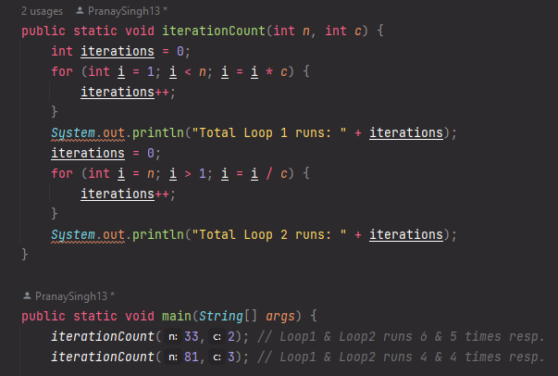
For Loop 1
n=33 | i=1 | n=81 | i=1
c=2 | i=2 | c=3 | i=3
 | i=4 |  | i=9
 | i=8 |  | i=27
 | i=16
 | i=32
As loop runs from i=1 and i is multiplied by constant factor c
C⁰, C¹, C², C³,- - - - - - C^{k-1}
C^{k-1} < n
k-1 log₂c <log₂n
k < log_{c}n + 1 Therefore we can say time complexity is O(log n).
For Loop 2
n=33 | i=33 | n=81 | i=81
c=2 | i=16 | c=3 | i=27
 | i=8 |  | i=9
 | i=4 |  | i=3
 | i=2
As loop runs from i=n and i is divided by constant factor c
$\frac{n}{c^{0}}$ , $\frac{n}{c^{1}}$ , $\frac{n}{c^{2}}$ , - - - - - - $\frac{n}{c^{k-1}}$
$\frac{n}{c^{k-1}}$ > 1
n > c^{k-1} or c^{k-1} < n
k < log_{c}n+1 Therefore we can say time complexity is O(log n).
One Real Time Example of Logarithmic Time Algorithm is Binary Search Algorithm.
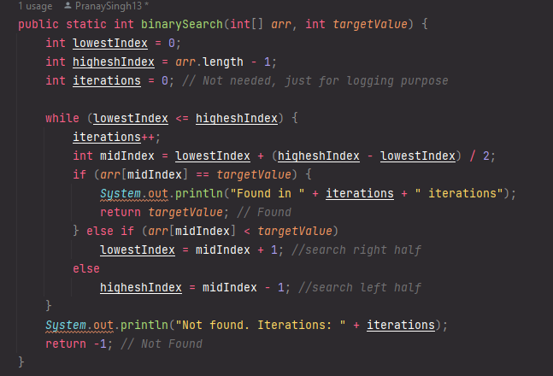
Each iteration halves the search space:
- n → n/2 → n/4 → n/8 → … → 1
After k steps: n / 2^k = 1 ⇒ k = log₂(n)
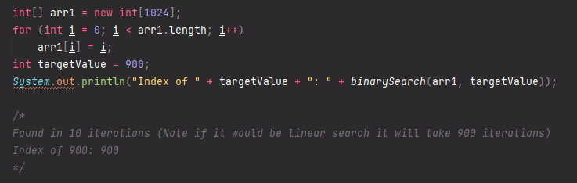

1.4.4 Linear Time Algorithm or O(n)
Time Complexity of a loop will be considered as O(n) if the loop variable is increment/decrement by a constant amount.
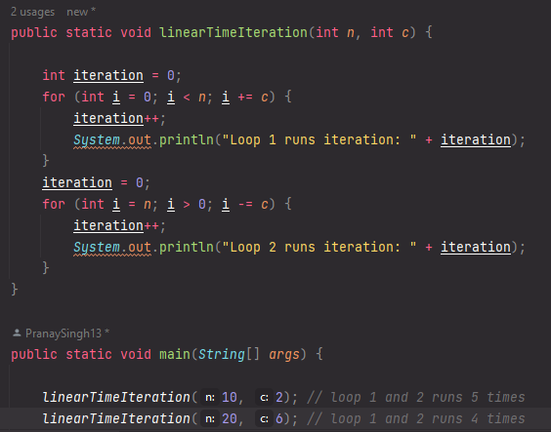

For Loop 1
n=10 | i=0 | n=20 | i=0
c=2 | i=2 | c=6 | i=6
 | i=4 |  | i=12
 | i=6 |  | i=18
 | i=8
Loop runs n/c times, we can say that Time Complexity is O(n).
For Loop 2
n=10 | i=10 | n=20 | i=20
c=2 | i=8 | c=6 | i=14
 | i=6 |  | i=8
 | i=4 |  | i=2
 | i=2

Loop runs n/c times, we can say that Time Complexity is O(n).
1.4.5 Polynomial Time Algorithm or O(n^{c})
Time Complexity of function can be considered as O(n^{c}) if nested loops is equals to the number of times the innermost statement is executed.
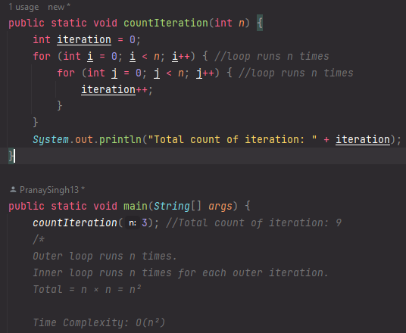
We can see for n=3, the inner most statement i.e.; iteration is incremented 9 times.
That is n² times, therefore we can say time complexity is O(n²)
When there are consecutive loops, we calculate the time complexity as sum of time complexity of individual.
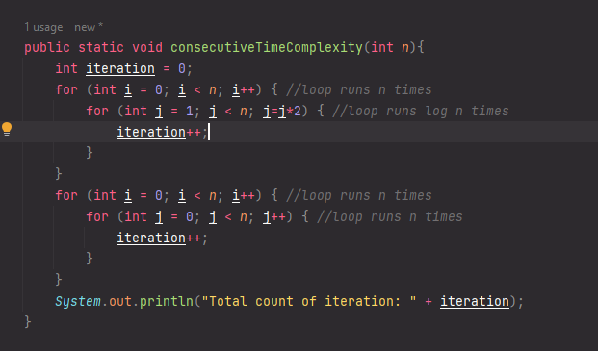
Overall Time Complexity = O(nlogn)+O(n²) => O(n²) as it is Higher Order term for input n.
1.4.6 Exponential Time Algorithm or O(c^{n})
An algorithm with time complexity O(cⁿ) (where c > 1, usually c = 2) is called exponential.
- The running time grows very rapidly as the input size n increases.
- Even small increases in n can cause the running time to explode.
- This is much slower than polynomial algorithms like O(n²) or O(n³).
Why it’s called exponential?
- If we plot O(cⁿ) versus n, the curve rises steeply.
- Example: if c = 2:
  - n = 10 → 2¹⁰ = 1,024 operations
  - n = 20 → 2²⁰ ≈ 1 million operations
  - n = 30 → 2³⁰ ≈ 1 billion operations
We can see the growth is not linear, not even quadratic—it's exploding exponentially.
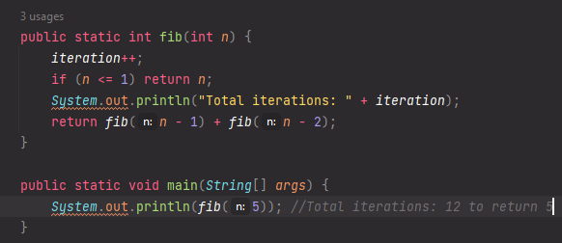
Time complexity: O(2ⁿ)
- Reason: Each call spawns two more calls, doubling work each step.
Think of exponential growth as branching trees:
- You have n levels, and at each level, you branch into c new possibilities.
- Total number of possibilities = c × c × c ... n times = cⁿ
- Even for medium-sized input (n = 50), the computation can become impractical.
- Usually, exponential algorithms are replaced with dynamic programming or approximation to reduce complexity to polynomial.

1.4.7 Factorial Time Algorithm or O(n!)
A factorial time algorithm is one whose time complexity grows as the factorial of the input size (n!).
That means:
$$T(n)=O(n!)=n×(n-1)×(n-2)×...×1$$
So as n increases, the number of possible operations or combinations grows extremely fast — even faster than exponential time algorithms like O(2ⁿ).
When does O(n!) occur?
Factorial time complexity usually appears in algorithms that try every possible permutation or ordering of a set of n items.
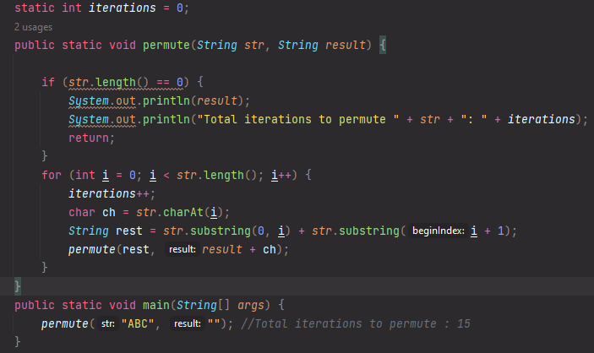
Here, the algorithm generates 3! = 6 permutations.
For n = 4, it generates 24,
for n = 10, it would generate 3,628,800 permutations — which quickly becomes infeasible.
Time Complexity Calculation
Each recursive call explores all remaining characters, so:
$$T(n)=n×T(n-1) \\ T(n)=O(n!)$$
1.5 Space Complexity
Space Complexity measures how much extra memory (space) your algorithm uses as the input size increases.
It includes:
- Input Space – memory used to store input.
- Auxiliary Space – memory used by the algorithm itself (like variables, recursion stack, data structures).
$$\text{Space Complexity}=\text{Input Space}+\text{Auxiliary Space}$$
We usually focus on Auxiliary Space, since input space is often fixed by the problem.
Constant Space (O(1))
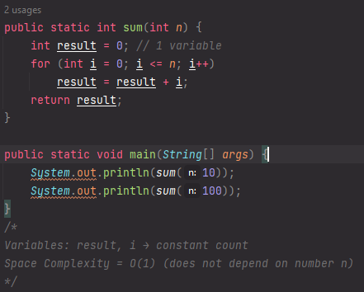
Logarithmic Space (O(log n))
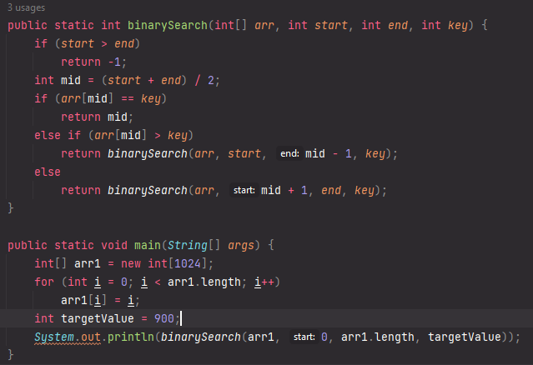
- Each recursive call splits the array in half.
- Depth of recursion = log₂(n)
✅ Space Complexity = O(log n) (recursion stack)
Linear Space (O(n))
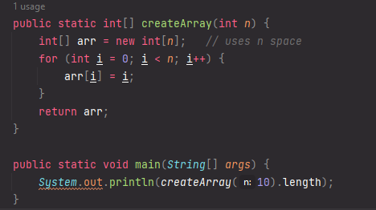
- arr requires memory proportional to n.
✅ Space Complexity = O(n)
Chapter 2: Mathematics
To get the last digit = $n ÷10$ To get the remaining digits => n/10
2.1 Arithmetic and Geometric Progression
An Arithmetic Progression (AP) is a sequence of numbers in which the difference between consecutive terms is constant. That difference is called the common difference (d).
Example: 2, 5, 8, 11, 14, …
Here:
- First term (a) = 2
- Common difference (d) = 5 - 2 = 3
Formula for n^{th} term in AP
T_{n} = a + (n-1) d where a is first term and d is the common difference between n terms.
Formula for Sum of first n terms in AP
S_{n} = $\left(\frac{n}{2}\right)*[2a+\left(n-1\right)d\}$
Formula for Arithmetic Mean
A.M. = $\frac{Sum of all terms in AP}{no of terms in AP}$
A Geometric Progression (GP) is a sequence where each term is obtained by multiplying the previous term by a fixed number (r), that number is the common ratio or the ratio of two consecutive terms is always same.
Example: 3, 6, 12, 24, 48, …
Here:
- First term (a) = 3
- Common ratio (r) = 6 / 3 = 2
Formula for n^{th} term in GP
T_{n} = a₁ * r^{(n-1)} where a₁ is first term and r is the common ratio between n terms.
Formula for Sum of first n terms in GP
S_{n} = $\frac{a\left(r^{n}-1\right)}{r-1} if r>1$ S_{n =} $\frac{a\left({1 - r}^{n}\right)}{1- r} if r<1$
Formula for Sum of infinite terms in GP
S_{n} = $\frac{a}{r-1} if r>1$ S_{n} = $\frac{a}{1- r} if r>1$
2.2 Quadratic Equations
A Quadratic Equation is a polynomial equation of degree 2, written in the standard form:
$$ax^{2}+bx+c=0$$
where:
- a, b, and c are constants (and a ≠ 0),
- x is the variable.
Formula to Find Roots
The Quadratic Formula gives the two possible roots of the equation:
$$x=\frac{-b±\sqrt{b^{2}-4ac}}{2a}$$
Here,
the expression inside the square root — (b² - 4ac) — is called the Discriminant (D).
$$D=b^{2}-4ac$$
2.3 Mean and Median
Mean (Average)
The mean (or average) is the sum of all values divided by the number of values.
$$\text{Mean}=\frac{\text{Sum of all values}}{\text{Number of values}}$$
Given numbers: 4, 8, 6, 5, 3
$$\text{Mean}=\frac{4+8+6+5+3}{5}=\frac{26}{5}=5.2$$Median
The median is the middle value when data is arranged in ascending (or descending) order.
- If n is odd, median = middle element.$Median=\left(\frac{n+1}{2}\right)$^{th} value where n is no of value
- If n is even, median = average of the two middle elements.
$$Median=\frac{\left(\frac{n}{2}\right)+\left(\frac{n}{2}+1\right)}{2}$$

Example 1 (Odd number of elements):
Data: 3, 5, 6, 8, 9
→ Median = 6 (middle element)
🧠 Example 2 (Even number of elements):
Data: 3, 5, 6, 8
→ Median = (5 + 6) / 2 = 5.5
2.4 LCM and HCF
LCM (Least Common Factor)
The smallest positive number that is a multiple of both numbers.
Example:
- Multiples of 12 → 12, 24, 36, 48, 60
- Multiples of 18 → 18, 36, 54, 72
✅ Common multiples → 36, 72, …
➡️ LCM = 36
HCF / GCD (Highest Common Factor / Greatest Common Divisor)
The largest number that divides two or more numbers exactly (without a remainder).
Example:
- Numbers: 12 and 18
- Factors of 12 → 1, 2, 3, 4, 6, 12
- Factors of 18 → 1, 2, 3, 6, 9, 18
✅ Common factors → 1, 2, 3, 6
➡️ HCF = 6
Relationship Between HCF and LCM
- For any two positive integers a and b:
$$\text{HCF(a, b)}×\text{LCM(a, b)}=a×b$$
This formula helps calculate one if the other is known.
- For any two fractions,
$HCF=\frac{HCF of Numerators}{LCM of Denominators}$ $LCM=\frac{LCM of Numerators}{HCF of Denominators}$
2.5 Prime Numbers
A prime number is a number greater than 1 that has no divisors other than 1 and itself.
Examples:
- Prime numbers → 2, 3, 5, 7, 11, 13, 17, 19 …
- Non-prime (composite) → 4, 6, 8, 9, 10, 12 …
Special Note:
- 1 is not a prime number nor composite.
- 2 is the only even prime number.
Every Prime number can be represented in 6n+1 or 6n-1 except for 2 & 3.
2.6 Factorials
The factorial of a number n (written as n!) is the product of all positive integers from 1 to n.
$$n!=n×(n-1)×(n-2)×…×2×1$$And, 0! = 1
Recursive definition:
$$n!=n×(n-1)!$$2.7 Permutations and Combinations
Permutation is defined as arrangement of r things that can be done out of n things where order matters that is changing the order makes it a new case.
Let’s say we have 3 letters: A, B, C and we want to pick 2 of them.
Permutation (Order Matters)
We care about what are possible arrangements of 2 letters:
AB, AC, BA, BC, CA, CB
Even though AB and BA use the same letters, they are different arrangements, because order changed.
Total = 6 permutations
Formula:
$$P(n,r)=\frac{n!}{(n-r)!}$$
Where:
- n = total number of items
- r = number of items to arrange
Combination (Order doesn’t matter)
Combination is defined as selecting of r things that can be done out of n things where order does not matter that is changing the order does not make it a new case.
We care only about which letters are chosen, not how they’re arranged.
Possible selections of 2 letters:
AB, AC, BC
AB and BA are same combination — both mean “A and B were chosen”.
Total = 3 combinations
Formula:
$$C(n,r)=\frac{n!}{r!(n-r)!}$$

2.8 Count Number of digits in a number
Concept of iteration
To count digits in a number, we repeatedly divide the number by 10 until it becomes 0.
Each division removes the last digit, so the number of divisions = number of digits.
Step 1: Initialize a counter
int count = 0;
Step 2: Check if the number is 0.
If it is, then it has exactly 1 digit.
Otherwise, proceed.
Step 3: Use a loop:
- While number is not 0:
  - Remove the last digit using number = number / 10
  - Increment count by 1
Step 4: When number becomes 0, stop.
The variable count now holds the total number of digits.
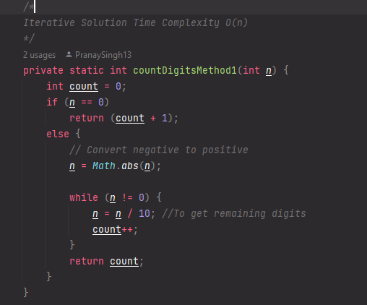

Concept of Recursion
Recursion means a function calls itself with a smaller version of the same problem until it reaches a base case (a condition to stop).
Here, we can divide the number by 10 repeatedly until it becomes 0 — just like before — but using a recursive function call instead of a loop.
Recursive Logic
For any integer n:
countDigits(n) = 1 + countDigits(n / 10)
Base case:
If n == 0 → return 0
But we must handle 0 carefully — if the number is 0, we should return 1.
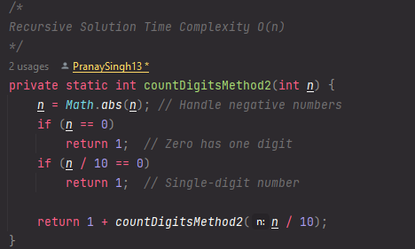
countDigits(5892)
│
├── 1 + countDigits(589)
│ │
│ ├── 1 + countDigits(58)
│ │ │
│ │ ├── 1 + countDigits(5)
│ │ │ │
│ │ │ ├── 1 + countDigits(0)
│ │ │ │ └── returns 0 ← Base case reached
│ │ │
│ │ └── returns 1 + 0 = 1
│ │
│ └── returns 1 + 1 = 2
│
└── returns 1 + 2 = 3
Now combine the last return:
countDigits(5892) → 1 + 3 = 4 ✅

Function Call | Calculation | Returned Value
countDigits(5892) | 1 + countDigits(589) | waits
countDigits(589) | 1 + countDigits(58) | waits
countDigits(58) | 1 + countDigits(5) | waits
countDigits(5) | 1 + countDigits(0) | waits
countDigits(0) | returns 0 | returns 0
countDigits(5) | 1 + 0 → 1 | returns 1
countDigits(58) | 1 + 1 → 2 | returns 2
countDigits(589) | 1 + 2 → 3 | returns 3
countDigits(5892) | 1 + 3 → 4 | ✅ returns 4
Final output → 4 digits
- Base case stops recursion (n == 0).
- Each recursive call counts one digit.
- Works for positive and negative numbers.
- For 0, handle separately since recursion returns 0 otherwise.

Concept of Logarithmic Approach
For any positive integer n,
the number of digits d is given by:
$$d=⌊{log⁡}_{10}(n)⌋+1$$
Why?
- log10(n) gives the position of the most significant digit in base 10.
- Example:
  - log10(1000) = 3.0 → floor(3) + 1 = 4 digits
  - log10(5892) ≈ 3.77 → floor(3.77) + 1 = 4 digits
Edge Cases to Handle
- When n == 0
  - log10(0) is undefined (throws Math domain error or returns -Infinity).
  - So handle 0 separately.
- When n < 0
  - Negative sign doesn’t count as a digit.
  - So take Math.abs(n) before applying the formula.
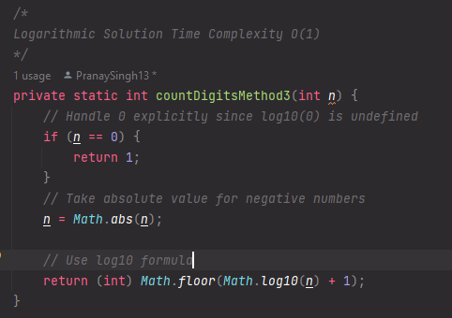
Input | log10(n) | floor(log10(n)) | Digits
5892 | 3.7708 | 3 | 4
9 | 0.9542 | 0 | 1
100 | 2.0000 | 2 | 3
0 | — | — | 1
-452 | 2.654 | 2 | 3
2.9 Check number is a Palindrome
A palindrome number reads the same backward as forward — for example, 121, 1331, and 1001.
Concept of Iterative Method (Reverse the Number) Approach
We reverse the digits of the number and compare it with the original.
Steps:
- Copy the number into a temporary variable (say original).
- Initialize reversed = 0.
- Extract the last digit using num % 10.
- Add it to reversed → reversed = reversed * 10 + digit.
- Remove the last digit from num → num = num / 10.
- Repeat until num becomes 0.
- If original == reversed, then it’s a palindrome.
Example:
For num = 121:
Step 1: digit = 1 → reversed = 1
Step 2: digit = 2 → reversed = 12
Step 3: digit = 1 → reversed = 121
Compare → 121 == 121 → palindrome ✅
Why it works:
Reversing the digits reconstructs the number backward. If that matches the original, the number reads the same both ways.
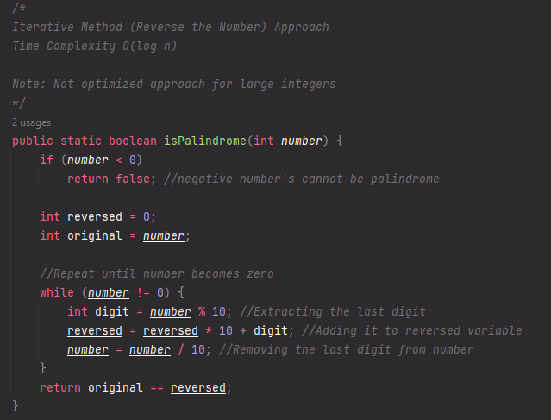
Concept of Optimized Half-Reverse Method Approach
Instead of reversing the whole number, reverse only half and compare the halves. This avoids overflow for large numbers and reduces unnecessary computation.

